**INTI International College Penang School of Engineering and Technology**

**3+0 Bachelor of Science (Hons) in Computer Science, in collaboration with Coventry University, UK**

**3+0 Bachelor of Science (Hons) in Computing, in collaboration with Coventry University, UK**

**Coursework cover sheet**

**Section A - To be completed by the student**

|  |  |
| --- | --- |
| Full Name:  OOI ZHONG QUAN | |
| CU Student ID Number:  8286572 | |
| Semester: 4 | |
| Lecturer:  Ms. CHERN HUEY RONG | |
| Module Code and Title:  205CDE DEVELOPING THE MODERN WEB 1 | |
| Assignment No. / Title: 205CDE COURSEWORK | % of Module Mark |
| Hand out date:  21ST AUGUST 2017 | Due date: |
| Penalties: No late work will be accepted. If you are unable to submit coursework on time due to extenuating circumstances you may be eligible for an extension. Please consult the lecturer. | |
| Declaration: I/we the undersigned confirm that I/we have read and agree to abide by the University regulations on plagiarism and cheating and Faculty coursework policies and procedures. I/we confirm that this piece of work is my/our own. I/we consent to appropriate storage of our work for plagiarism checking.  Signature(s): -------------------------------------- | |

**Section B - To be completed by the module leader**

|  |  |  |
| --- | --- | --- |
| Intended learning outcomes assessed by this work:   1. Install, configure and secure a web server ready for non-static content. Understand issues when setting-up web servers. 2. Identify from a variety of technologies to produce a range of standards based websites, incorporating multimedia contents. 3. Understand advantages of dynamic websites; Design and build data-driven dynamic websites that utilise both server-side and client-side scripting language technologies. | | |
| Marking scheme | Max | Mark |
| 1. Design10 2. HTML/CSSS/Javascript 3. Database 4. PHP 5. Report Writing 6. Coding 7. Video | 10  10  10  10  10  10  10 |  |
| Total | 70 |  |
| Lecturer’s Feedback | | |
| Internal Moderator’s Feedback | | |

*205CDE Developing the Modern Web 1*

**Assignment**

|  |  |  |  |  |  |  |
| --- | --- | --- | --- | --- | --- | --- |
| Issue Date: | 21 August 2017 |  |  |  |  |  |
| Deadline: | 20 November 2017 |  |  |  |  |  |
|  |  |  |
|  |  |  |  |  |  |  |

**1 INTRODUCTION**

There are two assessments in this module:

1. An online quiz will be delivered in the lab session via Blackboard during week No. 15 i.e. between 27th Nov 2017 – 1st Dec 2017. This will be worth **30%** towards your overall module score.

2. A reflective report on the website that you have developed and the accompanying Github repository that contains the source codes of your website. You also need to prepare and submit a short video that demonstrates your website. This will be worth **70%** towards your overall module score. The deadline for this is 20th November 2017.

**2 ASSESSMENTS 1 (30%)**

An online quiz will be delivered in the lab session via Blackboard and will be worth 30% towards your overall module score. These questions will be related to the previous lectures and are designed to test the recall of the facts taught in these lectures.

**Length**

The quiz will involve answering 30 randomly selected questions from a pool of multiple choice questions, and will last for one hour.

**Deadline**

27th Nov 2017 – 1st Dec 2017

**Marking**

The quizzes scores are automatically collected using Blackboard.

**3 ASSESSMENTS 2 (70%)**

**3.1 Requirements**

For this task you must design and implement your own website. You are expected to install, configure and secure a web server on your laptop. You are free to choose your own ideas for this website. You must:

1. You must be creative in designing you website. Your website needs to offer novel solutions or distinct features to other existing/similar websites.

2. You must use tools and technologies taught during this module such as HTML, CSS and JavaScript. However, you may use other tools and technologies, but tools and technologies used must be critically evaluated and justified why you have chosen to use these tools and technologies.

3. You must NOT use commercial software and/or 3rd party packages/libraries. For example, using Dream-weaver or Drupal to create your website is not allowed.

**1**

**Reflective Report**

You must submit a reflective report for the website you created. The word limit for your report is 1,500 words. Your report must:

1. Consider what you have learnt over the term.

2. Discuss each of the technologies you have used in creating the website.

1. Be reflective. For example, you must discuss your website was built in this way, and what you would do differently in the future.
2. Discuss area for improvement, strengths and weaknesses of your project.
3. Make good use of illustrative examples such as screenshots and code snippets.
4. On the cover page of your report, you must clearly mark a link to your Github repository where the source codes of your website can be accessed.
5. On the cover page of your report, you must clearly mark a link to your YouTube videocast.

**GitHub Repository**

You must create a GitHub repository that contains all source codes for your website. You must include the URL of your repository on the cover page of your report.

**Videocast**

You must prepare a short video of under 5 minutes that demonstrates how your website works. In this video, you must:

1. Show you website running on the screen and how to navigate it.

2. Explain features of your website and how those meet your design requirements.

3. Show parts of your source codes that implement the features mentioned above.

4. You must include a clear voice for explanation purposes.

5. The video must be produced in high quality so that technical details such as source codes can be clearly viewed.

6. You must upload your video to YouTube and include the URL of your video on the cover page of your report.

7. It is your responsibility to make sure the video can be watched by the academic marking your work. In order to do this, the privacy settings need to be set either Public or Unlisted.

**3.2 Submission**

The report must be submitted through Blackboard. You must clearly mark the links to your Github repository and YouTube videocast on the cover page of the report.

**Deadline**

11:59pm 20th November 2017

**Failing to submit the GitHub or YouTube links will result in a zero mark for this assessment.**



**2**

***Assignment***



**3.3 Marking**

The following rubric will be applied to your submission:



|  |  |  |  |  |  |  |
| --- | --- | --- | --- | --- | --- | --- |
|  | **0 – 2 points** | **3 – 4 points** | **5 – 6 points** | **7 – 8 points** | **9 – 10 points** |  |
|  | Poor web design. Improper  use of layout elements, fonts, and colours. Navigation is not  present, or not easy to follow. | It has basic layout and  structure, limited  implementation of navigation. | The layout is clear, and the  navigation is easy to follow.  It contains successful  attempts to implement  advanced design elements. | The website is visually appealing. It combines different design styles to suit different contents. | The website is of professional standards. It implements responsive design principles and suits different screen sizes and orientations. |  |
|  |  |
| **Design** |  |
|  |  |
|  |  |  |
|  | Very basic use of HTML and CSS. | Implement JavaScript  functions on top of HTML and CSS. But implementation of JS is very basic and limited. | Make use of various different types of HTML tags/attributes, and CSS rules. Successful attempts to incorporate Bootstrap  framework. | Combined HTML, CSS, JS, and  Bootstrap to successfully produce good layouts and visual effects. | The website makes extensive use of Bootstrap framework to a high standard. |  |
| **HTML** |  |
|  |
| **CSS** |  |
|  |
| **JavaScript** |  |
|  |
|  |  |
|  |  |
|  | No data collection on the  website. | Very basic data collection. No further validation or  processing. | Data are being validated/  processed. But database is not designed properly. | Data table are clearly defined and suitable for the type of data being collected. The whole database is properly normalized. | Database is carefully designed and optimized for speed. It includes advanced features such as indexing and triggers. |  |
| **Database** |  |
|  |
|  |  |
|  |  |
|  | The website makes no use of PHP. | Very basic templating. No  attempt to use database  system. | Basic use of both template  and database system. Basic levels of routing | Integrate various features using  PHP such as web forms and email support. | The website makes extensive use of PHP at high standard.  It shows trace of testing and debugging. |  |
| **PHP** |  |
|  |
|  |  |
|  |  |  |
|  | The report is poorly  structured, and contains lots of grammar mistakes and errors. | The report contains some  grammar mistakes. But  there’re lots of improper uses of screenshots and illustrations | The report makes proper use of screenshots and  illustrations. | The report is clearly structured with proper use of references. | The report is clearly structured and well written with little mistakes. |  |
| **Report** |  |
| **writing** |  |
|  |  |
|  | The student does not fully  understand the code used. | The website is fully functional but there are some comments, not sufficient enough to make  codes self-explanatory. | All codes are properly  documented in the comments. All codes are properly formatted. | The website makes proper use of programming techniques covered in the worksheets. All variable names and indentations etc. are consistent and follow specific conventions. | The website makes  appropriate use of advanced, cutting-edge programming techniques not mentioned during the course. |  |
|  |  |
| **Coding** |  |
|  |
|  |  |
|  |  |
|  |  |
|  | The video shows basic  functionality but poor  explanation of technical  issues. Low-quality audio. | Simple screencast that  demonstrates the working app and talks through the code. | A clear and detailed  screencast that is succinct and clear. | Edited video with simple titling.  High production values. | Professional-standard video  with high production values |  |
| **Video** |  |
|  |
|  |  |
|  |  |



Table of Contents

1.0 Introduction 8

1.1 Project Background 8

1.2 Technologies used 9

2.0 Webpage Design 11

3.0 Code Sample 16

4.0 Reflective 18

4.1 Self Reflective 18

4.2 Strength of Project 19

4.3 Weakness of Project 20

4.4 Future Suggestions 21

4.5 Summary 21

# 1.0 Introduction

## 1.1 Project Background

I have chosen to design a men fashion e-commerce website called The Lighters for my web developing assignment. The Lighters clothing store allows the publics to shop for their desired clothing materials on the internet without visiting physical clothing store like what older generations did. The Lighters provides free delivery service for the customers and free return and exchange of items. The Lighters offers few categories for the customers, like T-shirt, Polo T-shirt, Pants, Belts, Wallet, Underwear and Socks. However, customer will need to register as a member before buying an item on The Lighters and only able to buy an item after logging in his or her account. There is a purchase history page being shown to the customer where the customer able to check what have they bought in the past.

## 1.2 Technologies used

**HTML**

Figure 1.2.1 show example code of HTML. Hypertext Markup Language (HTML) is the standard markup language for creating web pages and web applications. With Cascading Style Sheets (CSS) and JavaScript it forms a triad of cornerstone technologies for the World Wide Web.

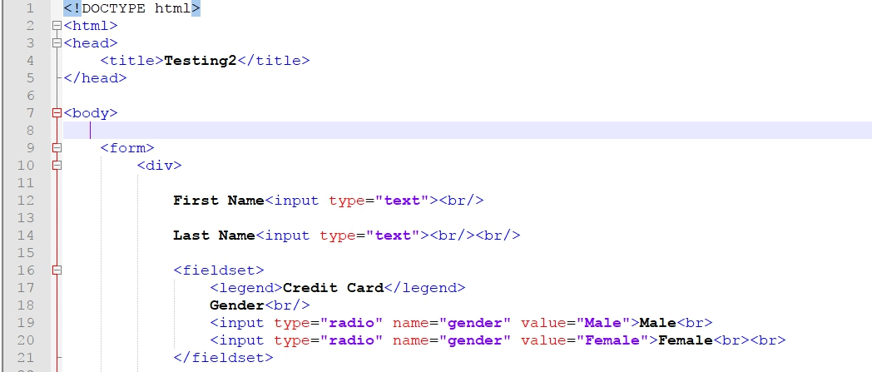

Figure .2.1 HTML Code

**CSS**

Figure 1.2.2 show example code of CSS. Cascading Style Sheets (CSS) is a style sheet language used for describing the presentation of a document written in a markup language.

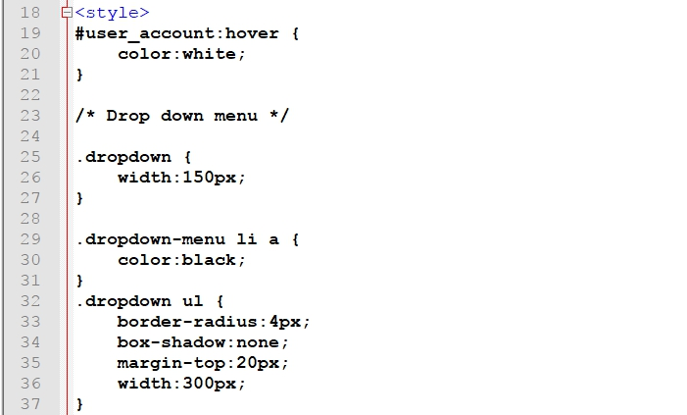

Figure 1.2.2 CSS Code

**JavaScript**

Figure 1.2.3 show example code of JavaScript. JavaScript is an interpreted programming language which is used to make webpages interactive and provide online programs.

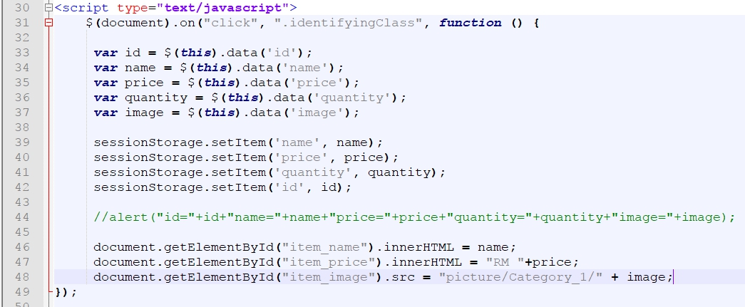

Figure 1.2.3 JavaScript Code

**PHP**

Figure 1.2.4 show example code of PHP. PHP is a server-side scripting language designed primarily for web development but also used as a general-purpose programming language.

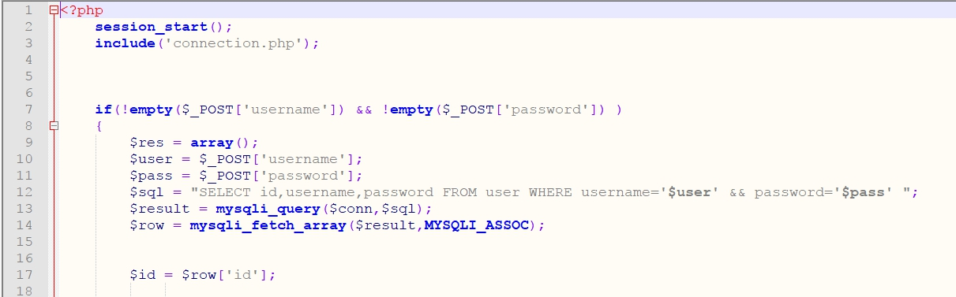

Figure 1.2.4 PHP Code

# 2.0 Webpage Design

**The Lighters – Home Page**

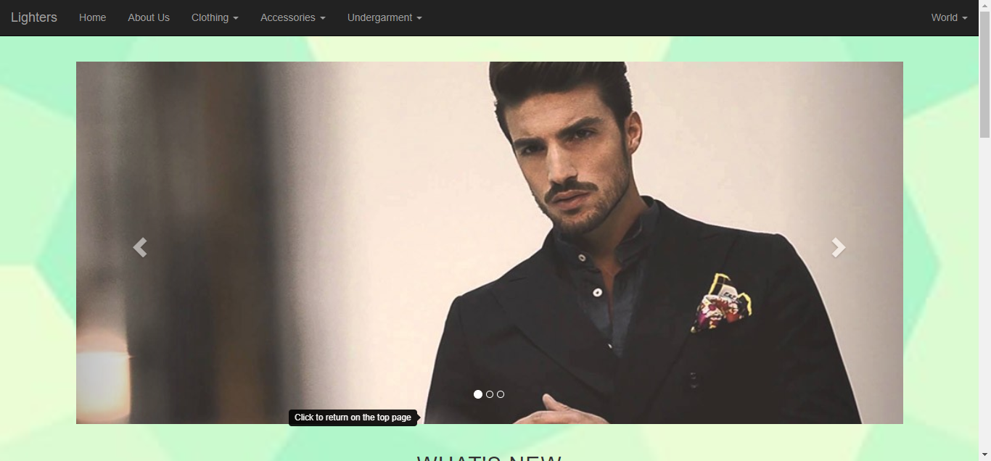

Diagram 2.0.1 Home Page of The Lighters

Diagram 2.0.1 shows the Home page of the website of The Lighters. Customers are shown the latest clothing materials available at our site and **sign up** or **log in** to our website at the top right corner of the web page. There are two sections, new arrival and also sales under the slideshow at the top of the page to let customer know which item is on sales or just arrived.

**The Lighters – About Us Page**

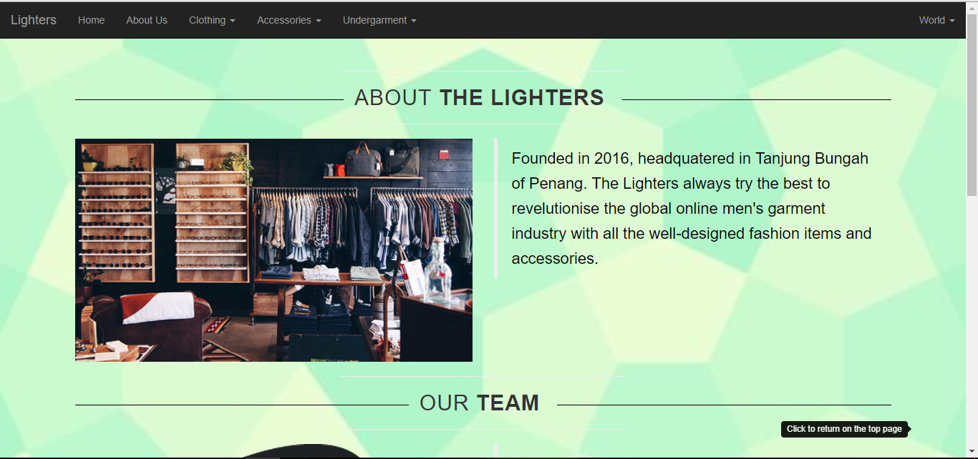

Diagram 2.0.2 About Us page of The Lighters

Diagram 2.0.2 shows the About Us page of The Lighters. Customers get to know more about the company background.



Diagram 2.0.3 Contact Us section of The Lighters

Diagram 2.0.3 shows the methods of the customers contacting the company.

**The Lighters – Product Page**

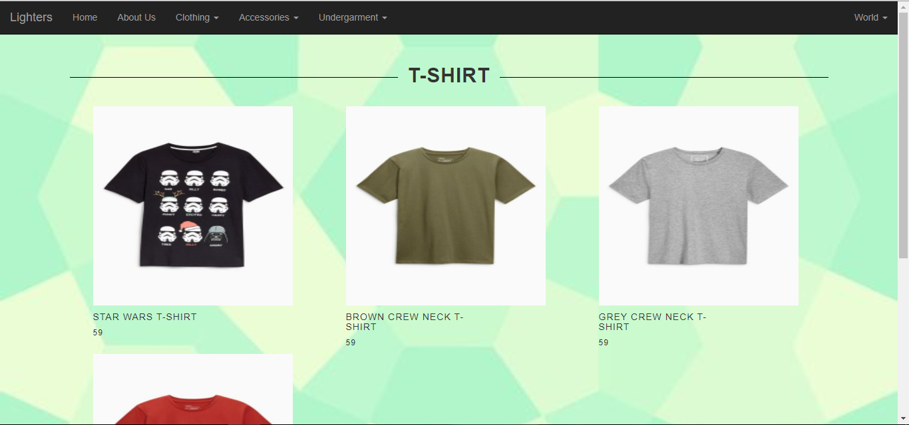

Diagram 2.0.4 Product page of The Lighters

Diagram 2.0.4 shows one of the product page of The Lighters.

**The Lighters – Product Detail Page**

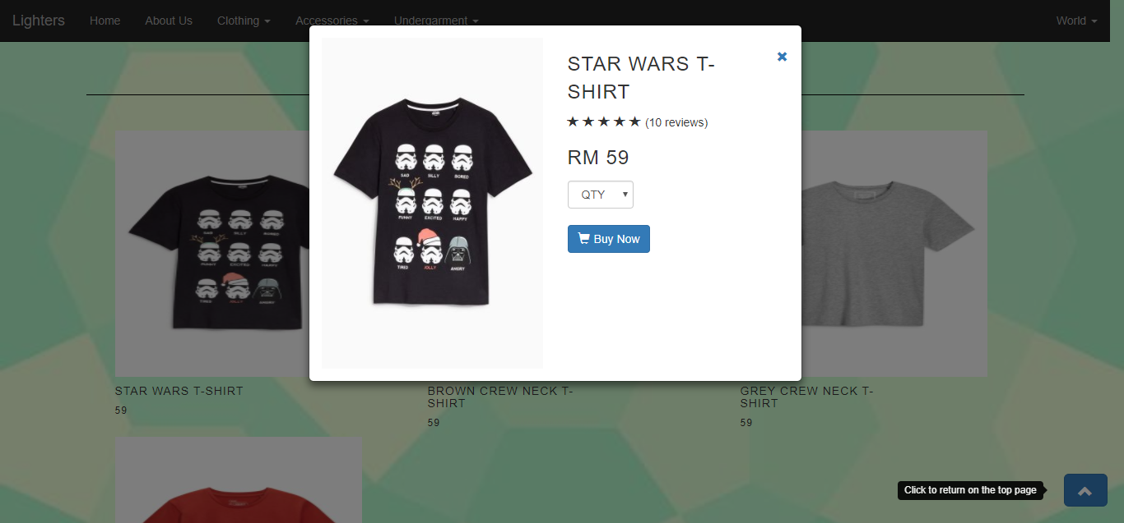

Diagram .0.5 Product detail page of The Lighters

Diagram 2.0.5 shows one of the product detail page of an item from The Lighters. Customer can choose the quantity that he or she wants to buy.

**The Lighters – Order Page**

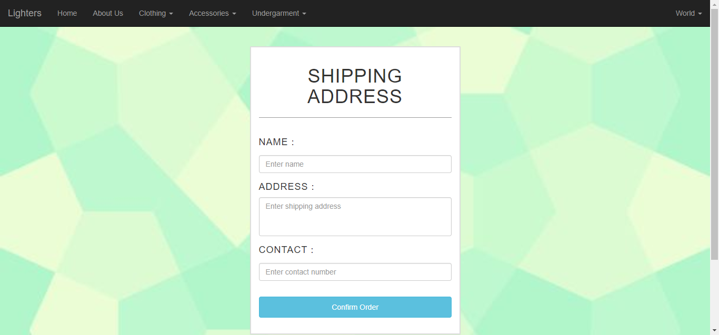

Diagram 2.0.6 Shipping Address form to be filled in by the customer

Diagram 2.0.6 shows the shipping address form to be filled in by the customer in order to place the order.

**The Lighters – Sign Up Page**

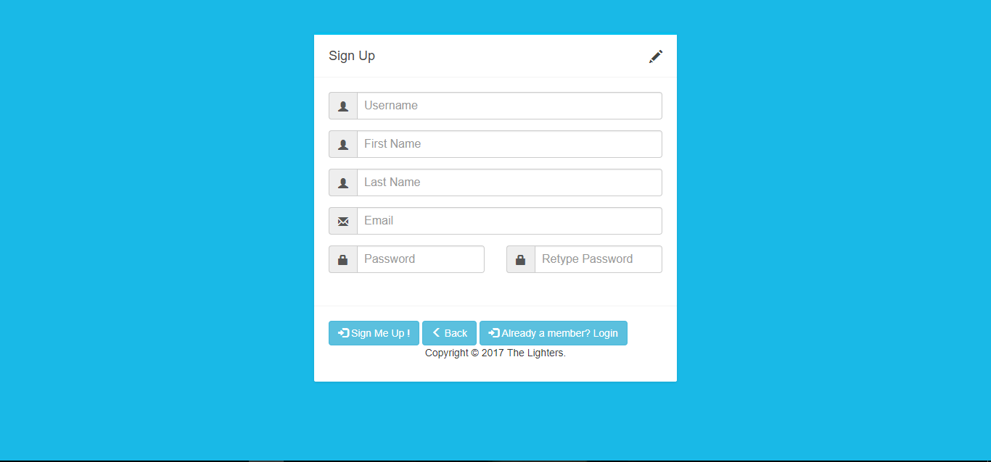

Diagram 2.0.7 Sign Up Form of The Lighters

Diagram 2.0.7 shows the Sign Up form of The Lighters when the customer wants to register themselves as a member to purchase something. There are real-time validation running at the background when user type in the required input.

**The Lighters – Log In Page**

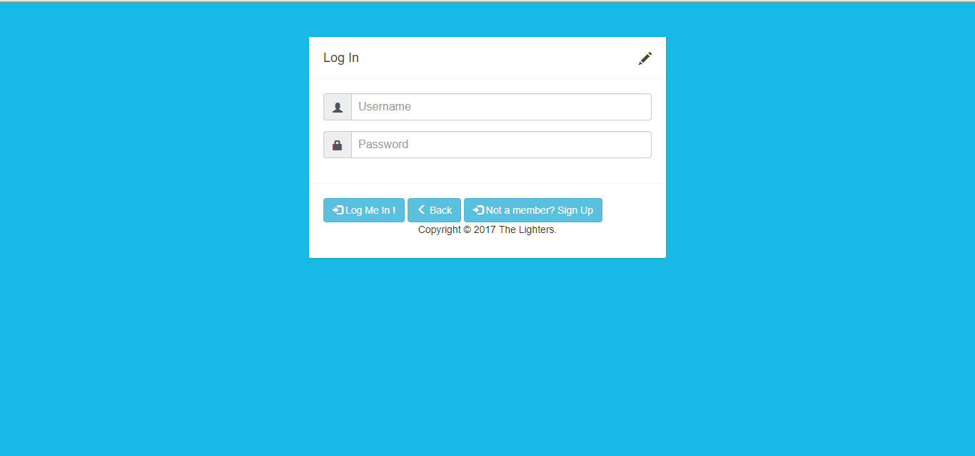

Diagram 2.0.8 Log In Form of The Lighters

Diagram 2.0.8 shows the Log In form of The Lighters. Members can log in through this page.

**The Lighters – Order History Page**

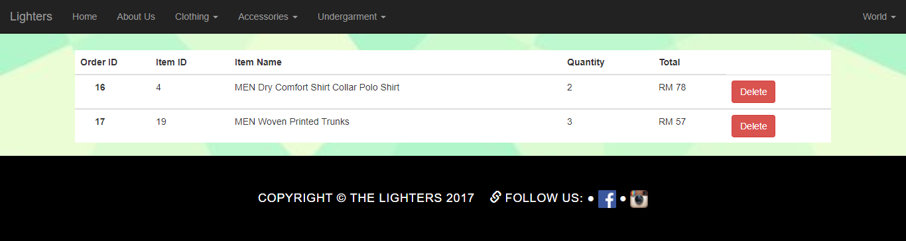

Diagram 2.0.9 Order History Page of The Lighters

Diagram 2.0.9 shows the Order History page of The Lighters. Members can view their purchased items at this page.

# 3.0 Code Sample

The data toggle and data target of the button in diagram 3.0.1 opens the popup modal which based on the id of the modal. For example, when user click on the button, the modal in diagram 3.0.2 that has the id which is product_view will be open.

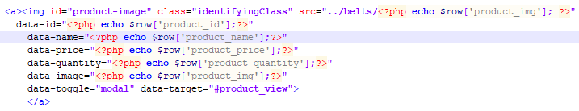

Diagram .0.1

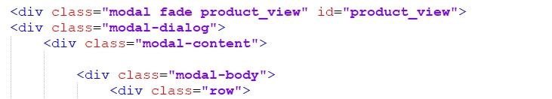

Diagram 3.0.2

In diagram 3.0.3, document.getElementById function is used in order to display the related information such as the price, quantity and image on the popup modal when user click to view the detail of the item.

sessionStorage.setItem function is used to temporally store the id of the product when user click to view the product detail. Thus, sessionStorage.getItem function will be used to get the id of the product at the end of the purchasing step which is the confirm product page.

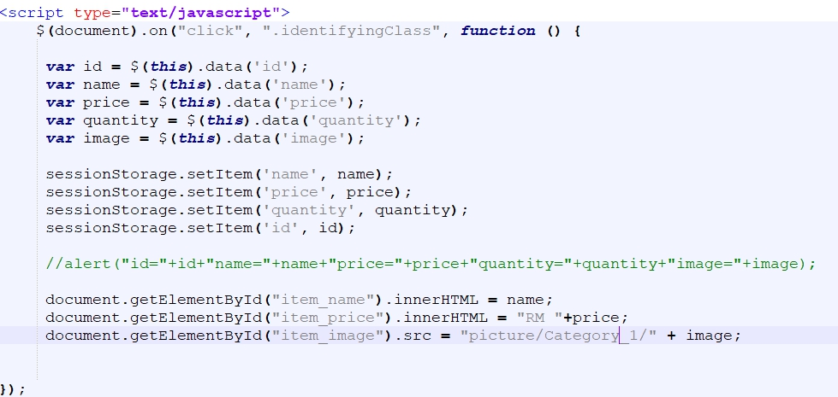

Diagram 3.0.3

In Diagram 3.0.4, there are validations. There are the validations for the Sign Up form. User will be prompted with live error message when user enter invalid inputs.

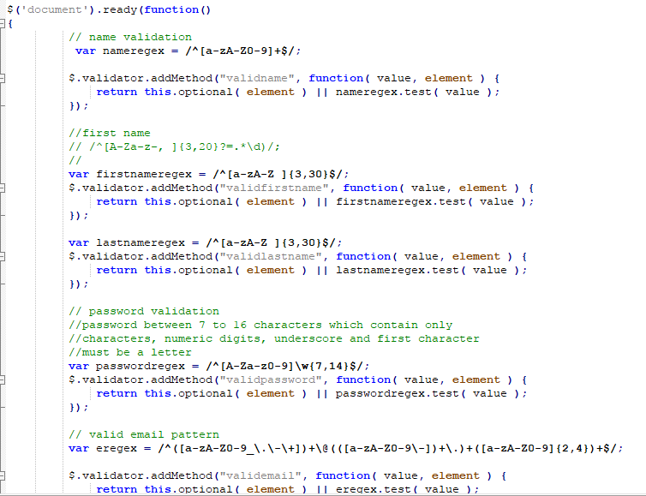

Diagram 3.0.

# 

# 4.0 Reflective

## 4.1 Self Reflective

I have become more self-independent than before after finishing the assignment. I do not have any idea or skill to develop the website thus I went and searched through the web to get some idea about it. My time management skill has improved after doing this project because I spent the spare times doing the project and managed to complete the project before the submission date as given by the tutor. The assignment itself is not a big deal, just that it need times to make it perfect or user-friendly to the most and the best.

I’m glad that my tutor, Ms Chern for teaching me a new programming language like PHP and a framework like Bootstrap to develop my website. My website is more beautified after implementing the framework Bootstrap as it provides many ready-to-go design and classes. It also gains myself more knowledge on website developing.

## 4.2 Strength of Project

The Sign Up form will be the strength of the project. The form is supported with real-time validation which reside in the register.js file. As the user key in the input into a particular input field, the input area will be validated with the validation pattern like input field for user name should contain only alphabets and digits. Besides Sign Up form, login function is another strength of the project. User will only able to make a purchase after they log in to his or her account.

Database is also implemented in this project. The images shown in the website are all retrieved from the folder, matched with the image file name and displayed. Besides displaying products, purchasing products, signing up, and logging in are all using database to get them working seamlessly. Session in PHP is also used to make sure the customer is logged in before purchasing any product.

The website separates the products into a few departments and users can click into different departments as the tabs shown in the navbar.

The website also provides pop-up modal to make user clearer about the item when an item is clicked. User can select the quantity of the product and they click the button beneath the quantity selection box to proceed.

## 4.3 Weakness of Project

One of the weaknesses can be found out in the website is that the dropdown lists would not show full drop-down menu when the user mouse over them. This is not user-friendly as people nowadays want everything to be user-friendly like you mouse over certain things and they will show the result. In this website, user will have to click the main tab first to show the full menu of certain category.

Besides drop-down menu, user is not able to know which section he or she is in. The navigation bar only shows few tabs for the user to click, so there’s no single indicator showing user which section is he or she in. User can only see the section name in the browser’s tab which is not professional.

Contact Us section is another weakness found in this website. The website doesn’t provide a contact form to let the user fill in, instead the website only displays the methods of reaching the company under ‘About Us’ section. The website should provide a contact form for the user other than display the methods only because this makes user feel unpleasant as they need to open his or her mailbox to compose the feedback to the company.

The website doesn’t have a shopping cart function which is not right at all. The user can’t choose multiple items that they want to buy and only fill in the shipping form once. The website needs user to fill in the shipping form once for each item.

Furthermore, the website doesn’t provide payment method for the user to make payment for his or her order.

## 4.4 Future Suggestions

Shopping cart is one of the feature to be added to the website because it is a necessary function for an e-commerce site to work in perfect conditions. User will feel more pleasant as he or she able to select multiple items before they want to make payment for them. Besides shopping cart, payment method should also be made available to the user. It is best advised not to let the user pay for the items through Cash on Delivery(COD) method.

## 4.5 Summary

In conclusion, the website is considered quite a successful project as it able to make the functions work correctly and precisely despite there are some flaws need to be fixed or improved.